II B. Tech. II Semester Supplementary Examinations – October, 2023

COMPUTER NETWORKS

Time: 150 Min (CSE(CS)) Max. Marks: 80M

SECTION – A
Answer all Four questions 4×10M=40M

1. Consider the following directed, weighted graph:
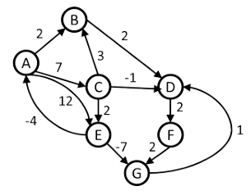
a) Even though the graph has negative weight edges, step through Dijkstra's algorithm to calculate supposedly shortest paths from A to every other vertex. Show your steps in the table below. Cross out old values and write in new ones, from left to right within each cell, as the algorithm proceeds. Also list the vertices in the order which you marked them known.
b) Dijkstra's algorithm found the wrong path to some of the vertices. For just the vertices where the wrong path was computed, indicate both the path that was computed and the correct path.
c) What single edge could be removed from the graph such that Dijkstra's algorithm would happen to compute correct answers for all vertices in the remaining graph?
==================================================================
2 a) Consider a short, 10-meter link, over which a sender can transmit at a rate of 150 bits/sec in both directions. Suppose that packets containing data are 100,000 bits long, and packets containing only control (e.g., ACK or handshaking) are 200 bits long. Assume that N parallel connections each get 1/N of the link bandwidth. Now consider the HTTP protocol, and suppose
that each downloaded object is 100 Kbits long, and that the initial downloaded object contains 10 referenced objects from the same sender. Would parallel downloads via parallel instances of non-persistent HTTP make sense in this case? Now consider persistent HTTP. Do you expect significant gains over the non-persistent case? Justify and explain your answer.
b) Consider the scenario introduced in the above problem. Now suppose that the link is shared by Bob with four other users. Bob uses parallel instances of non-persistent HTTP, and the other four users use non-persistent HTTP without parallel downloads.

i) Do Bob’s parallel connections help him get Web pages more quickly? Why or why not?
ii) If all five users open five parallel instances of non-persistent HTTP, then would Bob’s parallel connections still be beneficial? Why or why not?

3. Compare GBN, SR, and TCP (no delayed ACK). Assume that the timeout values for all three protocols are sufficiently long such that 5 consecutive data segments and their corresponding ACKs can be received (if not lost in the channel) by the receiving host (Host B) and the sending host (Host A) respectively. Suppose Host A sends 5 data segments to Host B, and the 2nd segment (sent from A) is lost. In the end, all 5 data segments have been correctly received by Host B.
a) How many segments has Host A sent in total and how many ACKs has Host B sent in total? What are their sequence numbers? Answer this question for all three protocols.

4. a) Give an overview of the distance vector method of updating routing table information.
In particularexplain using an example how information about a node failurepropagates using this algorithm.
b) What problem is encountered in deciding whether a host has become unreachable.
c) In what circumstances is it impossible to resolve this problem.

SECTION – B
Answer all Two questions 2×20M=40M

5. Assuming TCP Reno is the protocol experiencing the behaviour shown above, answer the following questions and justifying your answer.
a) Identify the intervals of time when TCP slow start is operating and when TCP congestion avoidance is operating.
b)After the 16thand 22ndtransmission round, is segment loss detected by a triple duplicate ACK orby a timeout?

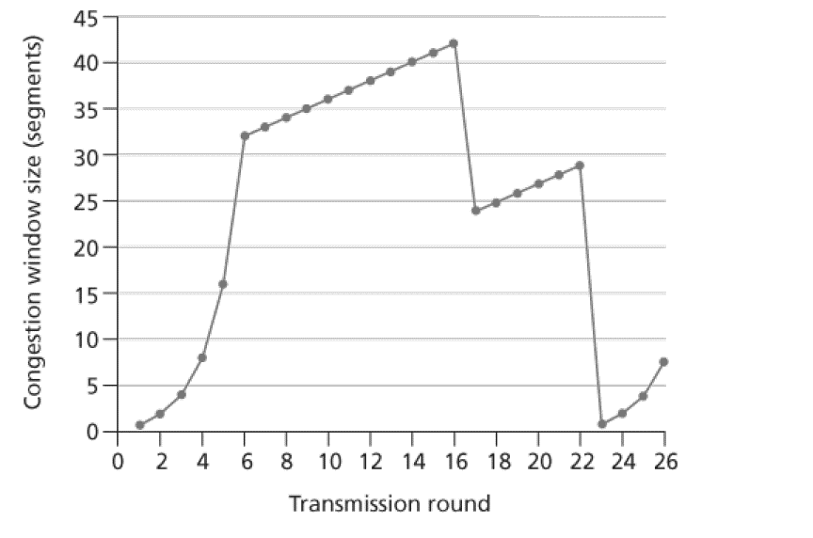
c) What is the initial value of ssthreshat the first transmission round? What is the value of ssthreshat the 18th and 24thtransmission round?
d) During what transmission round is the 70th segment sent?

e) Assuming a packet loss is detected after the 26th round by the receipt of a tripleduplicate ACK, what will be the values of the congestion window size and ofssthresh?
f) Suppose TCP Tahoe is used (instead of TCP Reno), and assume that triple duplicateACKs are received at the 16th round. What are the ssthreshand the congestionwindow size at the 19th round?
g) Again suppose TCP Tahoe is used, and there is a timeout event at 22nd round. Howmany packets have been sent out from 17th round till 22nd round, inclusive?

6. a) Consider the three-node topology shown in figure. Rather than having the link costs shown in figure, the link costs are Compute the distance tables
after the initialization step and after each iteration of a synchronous version of the distance vector algorithm

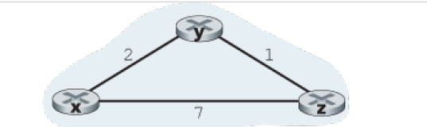

b) Consider the count-to-infinity problem in the distance vector routing. Will the count-to-infinity problem occur if we decrease the cost of a link? Why? How about if we connect two nodes which do not have a link?
c). Argue that for the distance-vector algorithm in figure, each value in the distance vector D(x) is non-increasing and will eventually stabilize in a finite number of steps.

